STRESS DISTRIBUTION IN SOILS DUE TO SURFACE LOAD
Estimate of vertical stresses at any point in a soil-mass due to external vertical loadings are of great significance in the prediction of settlements of buildings, bridges, embankments and many other structures. Equations have been developed to compute stresses at any point in a soil mass on the basis of the theory of elasticity. According to elastic theory, constant ratios exist between stresses and strains. For the theory to be applicable, the real requirement is not that the material necessarily be elastic, but there must be constant ratios between stresses and the corresponding strains. Therefore, in non-elastic soil masses, the elastic theory may be assumed to hold so long as the stresses induced in the soil mass are relatively small. Since the stresses in the subsoil o f a structure having adequate factor of safety against shear failure are relatively small in comparison with the ultimate strength of the material, the soil may be assumed to behave elastically under such stresses. When a load is applied to the soil surface, it increases the vertical stresses within the soil mass. The increased stresses are greatest directly under the loaded area, but extend indefinitely in all directions. Many formulas based on the theory of elasticity have been used to compute stresses in soils. They are all similar and differ only in the assumptions made to represent the elastic conditions of the soil mass. The formulas that are most widely used are the Boussinesq and Westergaard formulas. These formulas were first developed for point loads acting at the surface. These formulas have been integrated to give stresses below uniform strip loads and rectangular loads. The extent of the elastic layer below the surface loadings may be any one of the following:
1. Infinite in the vertical and horizontal directions.
2. Limited thickness in the vertical direction underlain with a rough rigid base such as a rocky bed.
The loads at the surface may act on flexible or rigid footings. The stress conditions in the elastic layer below vary according to the rigidity of the footings and the thickness of the elastic layer. All the external loads considered in this book are vertical loads only as the vertical loads are of practical importance for computing settlements of foundations.

BOUSSINESQ’S FORMULA FOR POINT LOADS
Figure 1 shows a load Q acting at a point 0 on the surface of a semi-infinite solid. A semi-infinite solid is the one bounded on one side by a horizontal surface, here the surface of the earth, and infinite in all the other directions. The problem of determining stresses at any point P at a depth z as a result of a surface point load was solved by Boussinesq (1885) on the following assumptions.
1. Th e soil mass is elastic, isotropic, homogeneous and semi-infinite.
2. The soil as a medium obey hooke’s law
3. The soil is weightless, i.e self-weight is ignored
4. The soil is initially unstressed
5. The change in volume of the soil upon application of load is neglected
6. The top surface of the medium is free of shear stress and subjected to only the point load at a specified location
7. Continuity of stress is considered to exist in the medium
8. The stresses are distributed symmetrically with respect to x-axis
9.The load is a point load acting on the surface.
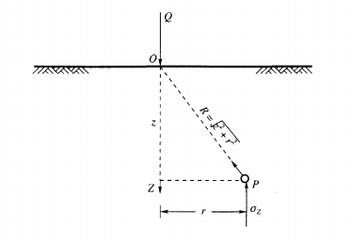
Figure 1: Vertical Pressure within an earth mass
The soil is said to be isotropic if there are identical elastic properties throughout the mass and in every direction through any point of it. The soil is said to be homogeneous if there are identical elastic properties at every point of the mass in identical directions. The expression obtained by Boussinesq for computing vertical stress σ_{z} at point P (figure 1) due to a point load Q is
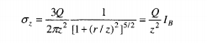……………………..eqn 1
Where, r = the horizontal distance between an arbitrary point P below the surface and the vertical axis through the point load Q.
z = the vertical depth of the point P from the surface.
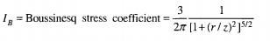
The values of the Boussinesq coefficient I_{B} can be determined for a number of values of $r/z$ . The variation of I_{B} with $r/z$ in a graphical form is given in fig 2 below.
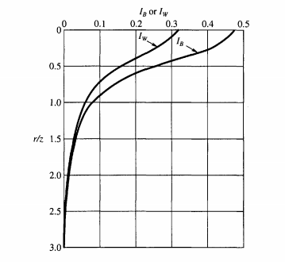
Figure 2: Values of I_{B} or I_{W} for use in the Boussinesq or Westergaard Formula
It can be seen from this figure that I_{B} has maximum value of 0.48 at = 0, i.e indicating thereby that the stress is a maximum below the point load.
WESTERGAARD’S FORMULA FOR POINT LOADS
Boussinesq assumed that the soil is elastic, isotropic, and homogeneous for the development of a point load formula. However, the soil is neither isotropic nor homogeneous. The most common type of soils that are met in nature are the water deposited sedimentary soils. When the soil particles are deposited in water, typical clay strata usually have their lenses of coarser materials within them. The soil s o f this type can be assumed as laterally reinforced by numerous, closely spaced, horizontal sheets of negligible thickness but of infinite rigidity, which prevent the mass as a whole from undergoing lateral movement of soil grains. Westergaard, a British Scientist, proposed (1938) a formula for the computation of vertical stress σ_{z} by a point load, Q, at the surface as
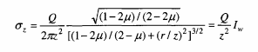……………………..eqn 2
In which µ is Poisson’s ratio. If µ is taken as zero for all practical purposes. The equation above simplifies to
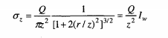………………………eqn 3
and, 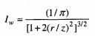
Where, I_{W} is the Westergaard stress coefficient. The variation of I_{W} with the ratios of (r/z) is shown graphically in figure 2 along with the Boussinesq’s coefficient I_{B}. The value of I_{W} at r/z = 0 is 0.32 which is less than that of I_{B} by 33 percent.
  - Example 1.
A concentrated load of 1000 kN is applied at the ground surface. Compute the vertical pressure (i) at a depth of 4 m below the load, (ii) at a distance of 3 m at the same depth. Use Boussinesq' s equation.
Solution
The equation is
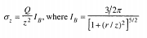
- When r/z = 0, I_{B} = 3/2π = 0.48
Hence, σ_{z} = 0.48 x Q/z²
= 0.48 x (1000/ 4 x 4) = 30 kN/m²

When r/z = ¾ = 0.75
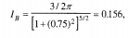
Hence, σ_{z} = 0.156 x Q/z²
= 0.156 x (1000/ 4 x 4) = 9.8 kN/m²
  - Example 2.
A concentrated loa d of 4500kN acts at foundation level at a depth of 2m below ground surface. Find the vertical stress along the axis of the load at a depth of 10m and at a radial distance of 5m at the same depth by (a) Boussinesq, and (b) Westergaard formula e for n = 0. Neglect the depth of the foundation.
Solution
(a) Boussinesq Equation:

Substituting the known values and simplifying
I_{B} = 0.2733 for r/z = 0.5
hence, σ_{z} = 0.48 x Q/z²
= 0.2733 x (4500/ 10²) = 12.3 kN/m²
(b) Westergaard Equation:

i.e

Substituting the known values and simplifying, we have I_{w} = 0.1733 for r/z = 0.5
Therefore, σ_{z} = 0.1733 x Q/z²
= 0.1733 x (4500/ 10²) = 7.8 kN/m²
Example 3
A rectangular raft of size 30 x 12 m founded at a depth of 2.5 m below the ground surface is subjected to a uniform pressure of 150 kPa. Assume the center of the area is the origin of coordinates (0,0). and the corners have coordinates (6,15). Calculate stresses at a depth of 20 m below the foundation level by the methods of (a) Boussinesq, and (b) Westergaard at coordinates of (0,0), (0,15), (6,0) (6,15) and (10,25). Also determine the ratios of the stresses as obtained by the two methods. Neglect the effect of foundation depth on the stresses.
Solution
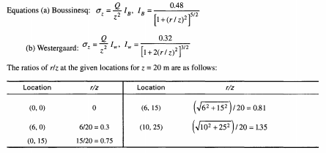
The stresses at the various locations at z = 20 m may be calculated by using the equations given above. The results are tabulated below for the given total load Q = qBL = 150 x 12 x 30 = 54000 kN acting at (0, 0) coordinate. Q/z² =135.
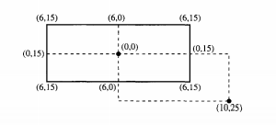

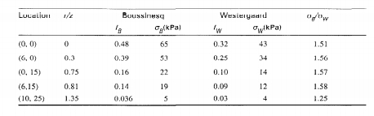
LINE LOADS
The basic equation used for computing σ_{z}, at any point P in an elastic semi-infinite mass is Eq. 1 of Boussinesq. By applying the principle of his theory, the stresses at any point in the mass due to a line load of infinite extent acting at the surface may be obtained. The state of stress encountered in this case is that of a plane strain condition. The strain at any point P in the Y-direction parallel to the line load is assumed equal to zero. The stress σ_{y} normal to the XZ-plane Fig.3 is the same at all sections and the shear stresses on these sections are zero. By applying the theory of elasticity, stresses at any point P (Fig. 3) may be obtained either in polar coordinates or in rectangular coordinates. Th e vertical stress σ_{z} at point P may be written in rectangular coordinates as
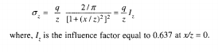………………….eqn 4
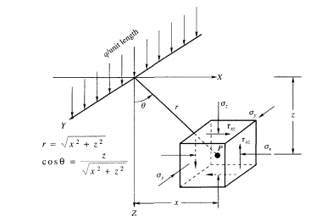
Figure 3: Stresses due to vertical line load in rectangular coordinates
STRIP LOADS
The state of stress encountered in this case also is that of a plane strain condition. Such conditions are found for structures extended very much in one direction, such as strip and wall foundations, foundations of retaining walls, embankments, dams and the like. For such structures the distribution of stresses in any section (except for the end portions of 2 to 3 times the widths of the structures from its end) will be the same as in the neighboring sections, provided that the load does not change in directions perpendicular to the plane considered. Fig. 4(a) shows a load q per unit area actin g on a strip of infinite length and of constant width B. The vertical stress at any arbitrary point P due to a line load of qdx acting at x = x can be written from Eq . (4) as
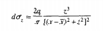……………………………………eqn 5
applying the principle of superposition, the total stress σ_{z} at point P due to a strip load distributed over a width B(= 2b) may be written as
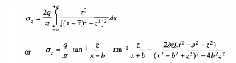……….eqn 6
The non-dimensional values of σ_{z}/q are given graphically in Fig. 5 . Eq. (6 ) can be expressed in a more convenient form as
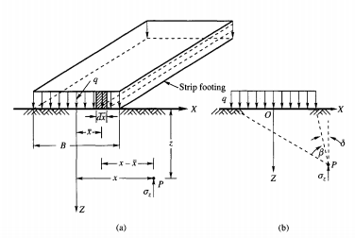
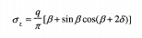 …………………………eqn 7
Figure 4: Strip Load
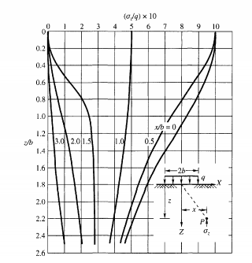
Figure 5: Non-dimensional values of σ_{z}/q for strip load
where β and δ are the angles as shown in Fig .4(b). Equation 7 is very convenient for computing σ_{z}, since the angles β and δ can be obtained graphically for any point P. The principal stresses σ₁ and σ₃ at any point P may be obtained from the equation
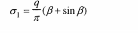…………………………….eqn 8
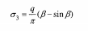………………………………….eqn 9
Example 4
Three parallel strip footings 3 m wide each and 5 m apart center to center transmit contact pressure s of 200, 150 and 100 kN/m² respectively. Calculate the vertical stress due to the combined loads beneath the centers of each footing at a depth of 3 m below the base. Assume the footings are placed at a depth of 2 m below the ground surface. Use Boussinesq's method for line load.
Solution:
From equation 4, we have;
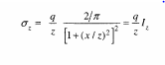
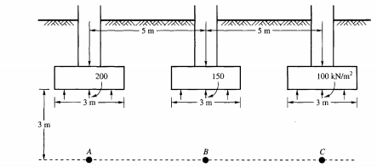
Three parallel footing
The stress at A is
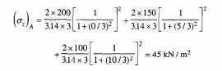
The stress at B is
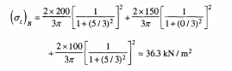
The stress at C is
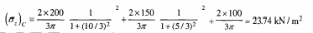

STRESSES BENEATH THE CORNER OF A RECTANGULAR FOUNDATION
Consider an infinitely small unit of area of size db x dl, shown in Fig. 6. The pressure acting on the small area may be replaced by a concentrated load dQ applied to the center of the area.
Hence, dQ = qdb.dl …………………………………eqn 10
The increase of the vertical stress σ_{z} due to the load dQ can be expressed per eqn 11
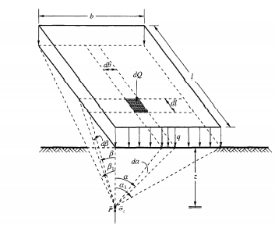
Fig 6: Vertical stress under the corner of a rectangular foundation
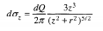……………………… eqn 11
The stress produced by the pressure q over the entire rectangle b x l can then be obtained by expressing dl, db and r in terms of the angles α and β, and integrating
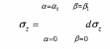…………………….eqn 12
There are several forms of solutions for eqn 12. The one that is normally used is of the following form
………………eqn 13
Or
σz =ql ……………………………..eqn 14
wherein, m = b/z, n = l/z, are pure numbers. I is a dimensionless factor and represents the influence of a surcharge covering a rectangular area on the vertical stress at a point located at a depth z below one of its corners. Eqn. 14 is presented in graphical form in Fig. 7. This chart helps to compute pressures beneath loaded rectangular areas. The chart also shows that the vertical pressure is not materially altered if the length of the rectangle is greater than ten times its width. Fig.8 may also be used for computing the influence value / based on the values of m and n and may also be used to determine stresses below points that lie either inside or outside the loaded areas as follows
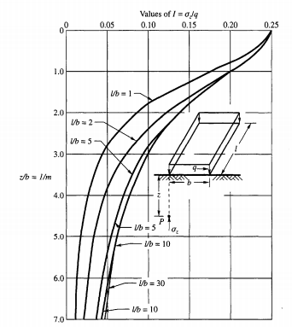
Fig 7: Chart for computing σ_{z} below the corner of a rectangular foundation (after Steinbrenner, 1934)
When the Point is Inside
Let O be an interior point of a rectangular loaded are a ABCD shown in Fig. 9(a). It is required to compute the vertical stress σ_{z} below this point O at a depth z from the surface. For this purpose, divide the rectangle ABCD in to four rectangles marked 1 to 4 in fig 9(a) by drawing lines through O. for each of these rectangles, compute the ratios z/b. the influence value I may be obtained from fig 7 or 8 for each of these ratios and the total stress at P is therefore
σ_{z} = q (I₁ + I₂ + I₃ + I₄) ………………………………………eqn 15
When the Point is Outside
Let O be an exterior point of loaded rectangular area ABCD shown in Fig. 9(b). It is required to compute the vertical stress σ_{z} below point O at a depth z from the surface. Construct rectangles as shown in the figure. The point O is the corner point of the rectangle OB1 CD1. From the figure it can be seen that
Area ABCD = OB₁CD₁ – OB₁BD₂-OD₁DA₁+OA₁AD₂ ………………….eqn 16
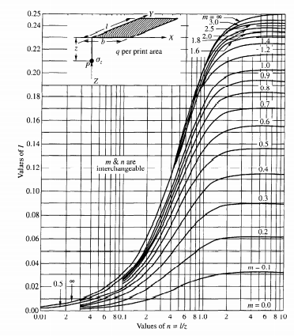
Fig 8: Graph for determining influence value for the vertical normal stress at point P located beneath one corner of a uniformly loaded rectangular area. (After Fadum, 1948)
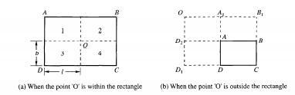
Fig 9: Computation of vertical stress below a point
The vertical stress at point P located at a depth z below point 0 due to a surcharge q per unit area of ABCD is equal to the algebraic sum of the vertical stresses produced by loading each one of the areas listed on the right-hand side of the Eqn. (16) with q per unit of area. If I₁ to I₄ are the influence factors of each of these areas, the total vertical stress is
σ_{z} = q (I₁ - I₂ - I₃ + I₄) …………………………..eqn 17
Example 5:
ABCD is a raft foundation of a multi-story building [Fig x] wherein AB = 20m, and
BC = 12m. The uniformly distributed load q over the raft is 350 kN/m². Determine σ_{z} at a depth of 6m below point O [Fig. x] wherein AA₁ = 4m and A₁0 = 6m. Use Fig. x

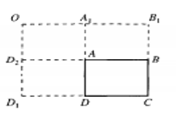
Fig. x
Solution
Rectangles are constructed as shown in [Fig. x].
Area ABCD = OB₁CD₁ – OB₁BD₂ - OD₁DA₁ + OA₁AD₂
Rectangle | L (m) | B(m) | M (b/z) | N (l/z) | I
OB₁CD₁  OB₁BD₂  OD₁DA₁  OA₁AD₂ | 26  26  16  6 | 16  4  6  4 | 2.67  0.67  1.00  0.67 | 4.33  4.33  2.67  1.00 | 0.245  0.168  0.194  0.145

Using equation 17,
σ_{z} = q (I₁ - I₂ - I₃ + I₄)
= 350 (0.245 – 0.168 – 0.194 + 0.145)
= 350 (0.028)
= 9.8 kN/m²
Example 6
A rectangular raft of size 30m x 12m founded on the ground surface is subjected to a uniform
Pressure of 150 kN/m². Assume the center of the area as the origin of coordinates (0, 0), and corners with coordinates (6, 15). Calculate the induced stress at a depth of 20m by the exact method at location (0, 0).
Solution
Divide the rectangle 12m x 30m into four equal parts of size 6m x 15m.
The stress below the corner of each footing may be calculated by using charts given in
Fig. 7 or Fig. 8. Here Fig. 7 is used.
For a rectangle 6m x 15m; z/b = 20/6 = 3.34
l/b = 15/6 = 2.5
For z/b = 3.34 and l/b = 2.5, σ_{z} /q = 0.07
Therefore, σ_{z} = 4 x 0.07q = 4 x 0.07 x 150 = 42 kN/m²
STRESSES UNDER UNIFORMLY LOADED CIRCULAR FOOTING
Stresses Along the Vertical Axis of Symmetry
Figure 10 shows a plan and section of the loaded circular footing. The stress required to be
determined at any point P along the axis is as the vertical stress cr,.
Let dA be an elementary area considered shown in Fig 10. dQ may be considered as the
point load acting on this area which is equal to q dA. We may write
dQ = q dA = qr dθ dr…………………………………..eqn. 18
The vertical stress dσ at point P due to point load dQ may be express
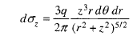………………………………….eqn. 19
The integral form of the equation for the entire circular area may be written as
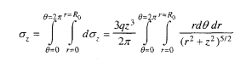
On integration we have,
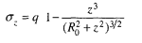 ……………… eqn 20
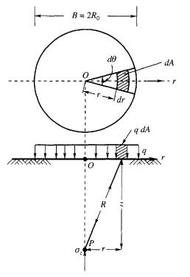
Fig. 10: Vertical stress under uniformly loaded circular footing
Or 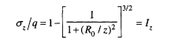…………….eqn 21
Where I_{z} is the influence coefficient, the stress at any point P on the axis of symmetry of a circular loaded area may be calculated by the use of eqn 21 vertical stress σ_{z} may be calculated by using the influence coefficient diagram given in fig 11.
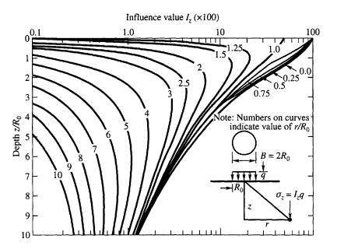
Fig. 11. Influence diagram for vertical normal stress at various points within an elastic half-space under a uniformly loaded circular area (After Foster and Ahlvin, 1954)
Example 7.
A water tank is required to be constructed with a circular foundation having a diameter of 16m founded at a depth of 2m below the ground surface. The estimated distributed load on the foundation is 325 kN/m². Assuming that the subsoil extends to a great depth and is isotropic and homogeneous, determine the stresses σ_{z} at points (i) z = 8m, r = 0, (ii) z = 8m, r = 8 m, (iii) z = 16m, r = 0 and (iv) z=16m, r = 8m, where r is the radial distance from the central axis. Neglect the effect of the depth of the foundation on the stresses. (Use Fig.11)
Solution
q = 325 kN/m², R_{o} = 8 m. The results are given in a tabular form as
 | Point | z/R_{o} | r/R_{o} | l | σ_{z} (kN/m²)
i | 8,0 | 1 | 0 | 0.7 | 227.5
ii | 8,8 | 1 | 1.0 | 0.33 | 107.25
iii | 16,0 | 2 | 0 | 0.3 | 97.5
iv | 16,8 | 2 | 1.0 | 0.2 | 65

VERTICAL STRESS BENEATH LOADED AREAS OF IRREGULAR SHAPE
Newmark’s Influence Chart
When the foundation consists of a large number of footings or when the loaded mats or rafts are not regular in shape, a chart developed by Newmark (1942) is more practical than the methods explained before. It is based on the following procedure. The vertical stress σ_{z}, below the center of a circular area of radius R which carries uniformly distributed load q is determined per Eq. 21. It may be seen from Eq. 21 that when R/z = ∞, σ_{z}/q=l, that is σ, = q. This indicates that if the loaded area extends to infinity, the vertical stress in the semi-infinite solid at any depth z is the same as unit load q at the surface. If the loaded area is limited to any given radius R₁ it is possible to determine from Eq .21 the ratios R/z for which the ratio of σ_{z}/q may have any specified value, say 0.8 or 0.6. Table 1 gives the ratios of R/z for different values of σ_{z}/q.
Table 1 may be used for the computation of vertical stress σ_{z} at any depth z below the center
of a circular loaded area of radius R. For example, at any depth z, the vertical stress σ_{z} = 0.8q if the radius of the loaded area at the surface is R = 1.387z. At the same depth, the vertical stress is σ_{z} = 0.7q if R = 1.110 z. If instead of loading the whole area, if only the annular space between the circles of radii 1.387z and 1.110z are loaded, the vertical stress at z at the center of the circle is Δσ_{z} =0. 8 q - 0.7 q = 0.lq. Similarly, if the annular space between circles of radii 1.110z and 0.917z are loaded, the vertical stress at the same depth z is Δσ_{z} = 0.7q - 0.6q = 0.1q. We may therefor e draw a series of concentric circles on the surface of the ground in such a way that when the annular space between any two consecutive circles is loaded with a load q per unit area, the vertical stress Δσ_{z} produced at any depth z below the center remains a constant fraction of q. We may write, therefore
Δσ_{z} = Cq …………………………..eqn 22
Where, C is constant. If an annular space between any two consecutive concentric circles is divided into n equal blocks and if any one such block is loaded with a distributed load q, the vertical stress produced at the center is, therefore
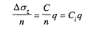…………………… eqn 23
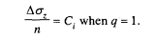
A load q = 1 covering one of the blocks will produce a vertical stress C_{i}. In other words, the influence value of each loaded block is C_{i}. If the number of loaded blocks is N, and if the intensity of load is q per unit area, the total vertical stress at depth z below the center of the circle is
σ_{z} = C_{i}Nq …………………….eqn 24
The graphical procedure for computing the vertical stress σ_{z} due to any surface loading is as follows
Select some definite scale to represent depth z. For instance a suitable length AB in cm as shown in Fig. 12 to represent depth z in meters. In such a case , the scale is 1 cm = z /AB meters. The length of the radius R_{0.8} which corresponds to σ_{z}/q = 0.8 is then equal to 1.387 x AB cm, and a circle of that radius may be drawn. This procedure may be repeated for other ratios of σ_{z}/q, for instance, for σ_{z}/q = 0.7, 0. 5 etc. shown in Fig. 12. The annular space between the circles may be divided into n equal blocks, and in this case n = 20. The influence value C. is therefore equal to 0.1/20 = 0.005. A plan of the foundation is drawn on a tracing paper to a scale such that the distance AB on the chart corresponds to the depth z at which the stress σ_{z} is to be computed. For example, if the vertical stress at a depth of 9 m is required, and if the length AB chosen is 3 cm, the foundation plan is drawn to a scale of 1 cm = 9/3 = 3 m. In case the vertical stress at a depth 12 m is required, a new foundation plan on a separate tracing paper is required. The scale for this plan is 1 cm = 12/AB = 12/3 = 4 m. This means that a different tracing has to be made for each different depth whereas the chart remains the same for all. Fig. 12(b) gives a foundation plan, which is loaded with a uniformly distributed load q per unit area. It is now required to determine the vertical stress σ_{z} at depth vertically below point O shown in the figure. In order to determine σ_{z}, the foundation plan is laid over the chart in such a way that the surface point O coincides with the center O' of the chart a s shown in Fig.12. The number of small blocks covered by the foundation plan is then counted. Let this number be N. Then the value of σ_{z} at depth z below O is σ_{z} = CiNq, which is the same as Eqn. 24
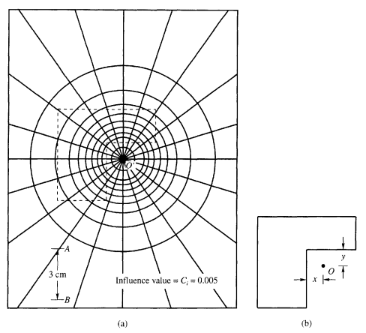
Figure 12 Newmark’s Influence Chart
Example 9
A ring footing of external diameter 8m and internal diameter 4m rests at a depth 2 m below the ground surface. It carries a load intensity of 150 kN/m². Find the vertical stress at depths of 2,4 and 8 m along the axis of the footing below the footing base. Neglect the effect of the excavation on the stress.
Solution
From equation 21, we have;
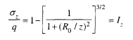
Where q = contact pressure 150kN/m2, Iz = influence coefficient.
The stress σ_{z} at any depth z on the axis of the ring is expressed as
σ_{z} = σ_{z1} - σ_{z2} = q (Iz₁ – Iz₂)
where σ_{z1} = stress due to the circular footing of diameter 8m, and Iz = Iz₁ and R_{o}/z = (R₁/z)
σ_{z2} = stress due to the footing of diameter 4m, and Iz = Iz₂ and R_{o}/z = (R₂/z)
Depth (m) | R₁/z | Iz₁ | R₂/z | I_{z2} | (I_{z1} – I_{z2})q = σ_{z}
2 | 2 | 0.911 | 1.0 | 0.697 | 39.6
4 | 1.0 | 0.647 | 0.5 | 0.285 | 54.3
8 | 0.5 | 0.285 | 0.25 | 0.087 | 29.7

Example 10.
A raft foundation of the size given in fig 10, carries a uniformly distributed load of 300 kN/m². Estimate the vertical pressure at a depth 9m below the point O marked in the figure.
Solution
The depth at which σ_{z} required is 9 m. Using Fig.12, the scale of the foundation plan is AB = 3 cm = 9m or 1 cm = 3m. The foundation plan is required to be made to a scale of 1cm = 3m on tracing paper. This plan is superimposed on Fig.12 with O coinciding with the center of the chart. The plan is shown in dotted lines in fig 12.
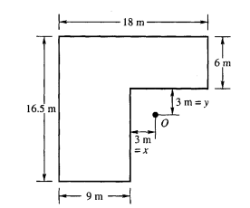
Fig 10 Building Foundation Plan
Number of loaded blocks occupied by the plan, N = 62
Influence value Ci = 0.005, q = 300 kN/m²
The vertical stress σ_{z} = CiNq = 0.005 x 62 x 300 = 93 kN/m²
PRESSURE ISOBAR
An isobar is a line which connects all points of equal stress below the ground surface. In other words, an isobar is a stress contour. We may draw any number of isobars as shown in Fig. 6.19 for any given load system. Each isobar represents a fraction of the load applied at the surface. Since these isobars form closed figures and resemble the form o f a bulb, they are also termed bulb of pressure or simply the pressure bulb. Normally isobars are drawn for vertical, horizontal and shear stresses. The one that is most important in the calculation of settlements of footings is the vertical pressure isobar.
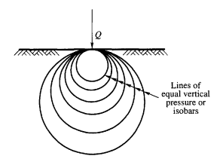
Fig 13 Bulb of pressure
SIGNIFICANT DEPTH
Terzaghi stressed the importance of the bulb of pressure and its relationship with the seat of settlement. As stated earlier we may draw any number of isobars for any given load system, but the one that is of practical significance is the one which encloses a soil mass which is responsible for the settlement of the structure. The depth of this stressed zone may be termed as the significant depth Ds which is responsible for the settlement of the structure. Terzaghi recommended that for all practical purposes one can take a stress contour which represents 20 per cent of the foundation contact pressure q, i.e, equal to 0.2q. The depth of such an isobar can be taken as the significant depth Ds which represents the seat of settlement for the foundation. Terzaghi's recommendation was based on his observation that direct stresses are considered of negligible magnitude when they are smaller than 20 per cent of the intensity of the applied stress from structural loading, and that most of the settlement, approximately 80 per cent of the total, takes place at a depth less than Ds . The depth Ds is approximately equal to 1. 5 times the width of square or circular footings [Fig. 14(a)]. If several loaded footings are spaced closely enough, the individual isobars of each footing in question would combine and merge into one large isobar of the intensity as shown in [Fig. 14(b)]. The combined significant depth Ds is equal to about 1. 5 B.
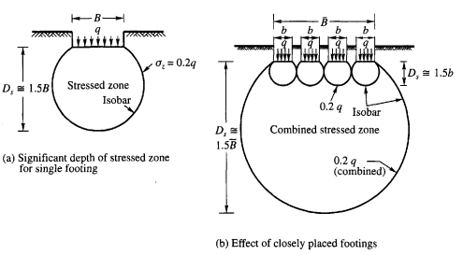
Fig 14. Significant depth of stressed zone
Pressure Isobars for Footings
Pressure isobars of square, rectangular and circular footings may conveniently be used for determining vertical pressure, σ_{z}, at any depth, z, below the base of the footings. The depths z from the ground surface, and the distance r (or x ) from the center of the footing are expressed as a function of the width of the footing B. In the case of circular footing B represents the diameter.
The following pressure isobars are given based on either Boussinesq or Westergaard' s equations
1. Boussinesq isobars for square and continuous footings, Fig. 15.
2. Boussinesq isobar for circular footings, Fig. 16.
3. Westergaard isobars for square and continuous footings, Fig. 17.
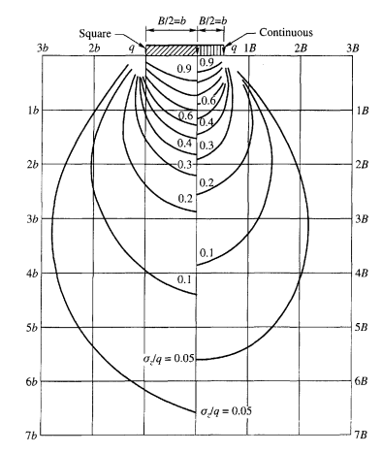
Fig 15 pressure isobars based on Boussinesq equation for square and continuous footing
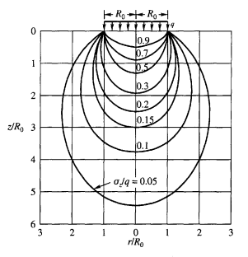
Fig 16. Pressure isobars based on Boussinesq equation for uniformly loaded circular footings
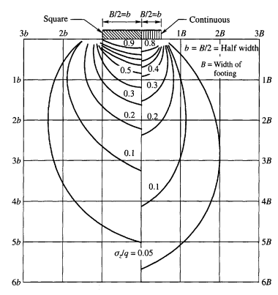
Fig 17. Pressure isobars based on Westergaard equation for square and continuous footings
Example 11
A single concentrated load of 1000kN acts at the ground surface. Construct an isobar for σ_{z} = 40kN/m2 by making use of the Boussinesq equation.
Solution
From equation 1, we have
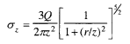
We may now write by rearranging an equation for the radial distance r as
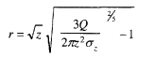
Now for Q = 1000kN, σ_{z} = 40kN/m², we obtain the values of r₁, r₂, r₃,…etc for different depths z₁, z₂, z₃,….etc. the values so obtained are;
z (m) | r (m)
0.25 | 1.34
0.5 | 1.36
1.0 | 1.30
2.0 | 1.04
3.0 | 0.60
3.455 | 0.00
The isobar for σ_{z} = 40kN/m² may be obtained by plotting z against r as shown below.
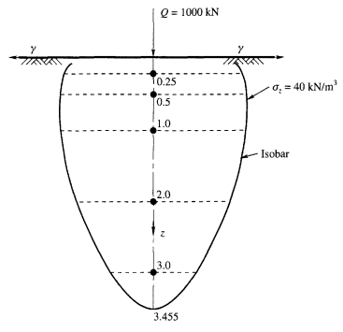
FOUNDATION
Foundation is the lowest part of a structure which is in contact with soil and transmits loads to it.
The type of foundation utilized is closely related to the properties of the supporting soil, since the performance of the foundation is based on that of the soil, in addition to its own.
TYPES OF FOUNDATION
The various types of foundation e.g. Strip, pad, raft, pile etc. can be grouped into two (2) broad categories.
Shallow Foundation: If the depth of the footing is less than or equal to width.
Deep Foundation: If the depth is far more than the width.
Shallow – Z ≤ B
Deep – Z > B (Terzaghi)
CHOICE OF FOUNDATION TYPE
The type of foundation most appropriate for a given structure depends upon several factors.
- The function of the structure and the loads it must carry.
- The subsurface condition
- The cost of the foundation in comparison with the cost of the superstructure.

FACTORS TO CONSIDER IN FOUNDATION DESIGN
The following are some of the factor to be considered in foundation design;
- Footing Depth and Spacing
Footings should be carried below
i. The frost line
ii. Zones of high volume change due to moisture fluctuations
iii. Topsoil or organic material
iv. Peat and muck
v. Unconsolidated material such as abandoned (or closed) garbage dumps and similar filled in areas.
Footings should be placed below the frost line because of possible frost heave of the buildings and because alternate freezing and thawing of the soil tends to maintain it in an unconsolidated or loose state. Footings should also be placed below any topsoil layer, for topsoil is loose and usually contains organic matter.
- Displaced Soil Effects
Soil is always displaced by installing a foundation. In the case of spread footings the displacement is the volume of the footing pad and the negligible amount from the column resting on the footing. In cases where a basement is involved, the basement floor slab usually rests directly on top of the footing pad.
- Erosion problems for structures adjacent To flowing water
Bridge piers, abutments, bases for retaining walls, and footings for other structures adjacent to or located in flowing water must be located at a depth such that erosion or scour does not undercut the soil and cause a failure. The scour depth will depend on the geological history of the site (depth of prior erosion to bedrock and subsequent redeposition of sediments, stream velocity, and area runoff).
- Corrosion Protection
In polluted ground areas such as old sanitary landfills, shorelines near sewer outfall lines from older industrial plants, or backwater areas where water stands over dead vegetation, there can be corrosion problems with metal foundation members as well as with concrete. Concrete is normally resistant to corrosion; however, if sulfates are present, it may be necessary to use sulfate-resistant concrete. It may occasionally be necessary to use air-entrained concrete for foundation members.
- Water Table Fluctuation
A lowered water table increases the effective pressure and may cause additional settlements.
A raised water table may create problems for the owner from the following:
i. Floating the structure (making it unstable or tilting it)
ii. Reducing the effective pressure (causing excessive settlements)
iii. Creating a wet basement if the basement walls are not watertight
These problems can usually be solved by introducing some type of drainage so that water does not accumulate around the building walls or produce hydrostatic uplift beneath the basement. The use of drain tile around the basement perimeter is common for residential dwellings and some larger buildings. In other cases a sloping basement excavation that is backfilled with granular material to the required horizontal level in combination with a well (called a sump pit) at the low point that is fitted with a pump (a sump pump system) can be used.
- Foundations on Permafrost
Permafrost is a condition of permanently frozen ground where the ground temperatures are never higher than 0˚C. Construction in these areas requires that the foundations be placed below this material and into the permafrost. It is usually necessary to insulate the interface between structure and the permafrost so that thawing of the underlying permafrost does not occur, either from building heat or because of changed environmental conditions. Pile foundations are more reliable for permafrost areas but are much more expensive.

- Environmental Considerations
Foundation engineers have the responsibility to ensure that their portion of the total design does not have a detrimental effect on the environment. The responsibility may be enforceable by the courts if a laxity on the part of any parties can be ascertained. Although it may not be readily apparent, the foundation engineer does have some effect or potential effect on the environment, for example:
i. Soil borings through sanitary landfills (which may have been constructed on impervious soil to avoid groundwater pollution) can pollute the groundwater via seepage through the boreholes.
ii. Soil boring logs should be checked for indication of effect of site excavation on the environment in terms of runoff, pollution in runoff, odor problems, dust, and noise.
iii. One should investigate means to salvage topsoil for landscaping.
iv. Pile driver noise and vibration can be objectionable.
v. Alternatives to cutting trees either for site work or where trees cause seasonal volume changes from soil desiccation during the growth season and wetting during the dormant season should be established.
vi. Effect of soil borings on perched water tables must be identified.
vii. It should be determined whether soil borings near streams cause piping problems during high water periods. These may be avoided by careful plugging of the boreholes.
viii. Hydraulic fill for cofferdams, roadway approaches, and retaining structures, usually obtained from river bottoms, must not cause pollution of the groundwater through loss of the relatively impervious silt layer in the stream bed.
ix. Earth removal for fill from hillsides must not cause landslides, which may destroy scenic areas.
x. The effect of river and marine structures on aquatic life must be minimized.
xi. River and marine structures may lead to pollution of groundwater by either river or saltwater intrusions.
SPREAD FOOTING
Spread footings are most widely used type among all foundation because they usually more economical than other. Common types of spread footings are;
- Plain or simple footing: it is usually of reinforced concrete and is used to support a reinforced concrete column.
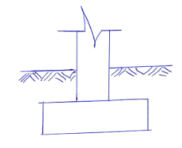
- Mass concrete footing is used to support a steel column.
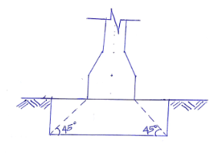
- Sloped footing usually have the same materials as that of column and alternatively, it can be of reinforced concrete.
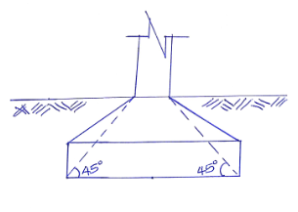
- Stepped footing is used either for a column or for a walls. All the steps may be of concrete or the bottom most step alone may be concrete, the other being of the same material as for the column.
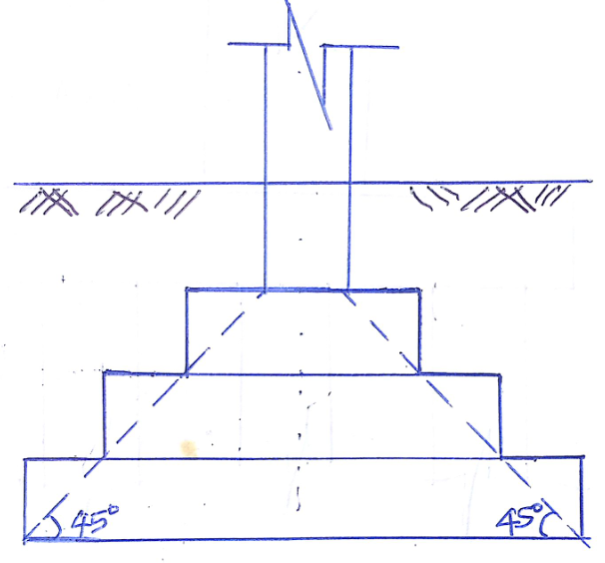
RAFT FOUNDATION
A raft or a mat foundation is a combined footing which covers the entire area beneath of a structure and supports all the walls and column. This type of foundation is most appropriate and suitable when the allowable soil pressure is low or the loading heavy, or when the soil contains lenses of compressible strata which are likely to cause considerable differential settlement.
Common types of raft foundations are;
- Flat slab type: This is flat concrete slab of uniform thickness throughout the entire area. It is suitable for closely spaced columns carrying small load. See fig. below
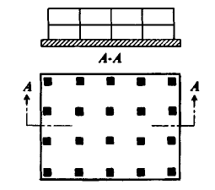
- Flat slab thickened under columns it provides sufficient strength for relatively large column loads, See fig. below
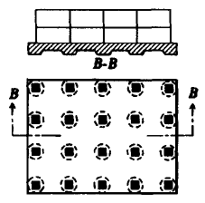
- Two way beam and slab type thickened bands provided along column lines in both directions, this provides sufficient strength when the column spacing is large and column loads unequal. See fig. below
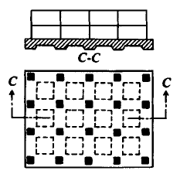
- Flat slab with pedestals: It is a raft in which pedestals are provided under each column, See fig. below

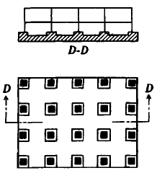
- Basement walls as rigid frame represent a raft wherein basement walls have been used as ribs or deep beams, . See fig. below
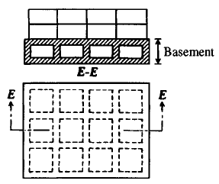
- Cellular type is a two-way grid structure made of cellular construction and of intersecting structural steel construction, See fig. below
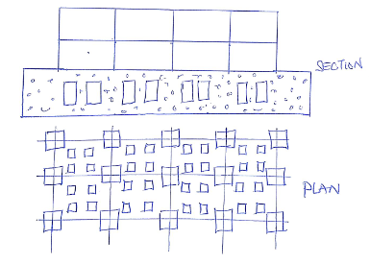
PILE
A pile is a slender structural member made of steel, concrete or wood. It is driven into the soil or formed in-situ by excavating a hole and filling it with concrete.
Pile foundations are used in the following conditions.
- When the strata at or just below the ground surface is highly comprehensible and very weak to support load.
- When the plan of the structure is irregular relative to its outline and load distribution.
- It requires for the transmission of structural loads through deep water to a firm structure.
- It is used for resist horizontal forces in addition to support the vertical loads in the earth-retaining structures and tall structure.
- It is required when soil conditions are such that a wash out, erosion of soil may occur from underneath a shallow foundation.
- It is used for foundations of some structures such as transmission towers.
- It is used to transfer load below the active zone in case of expansive soils.
- It is used to transfer load beyond the zone of possible moisture changes in collapsible soils such as loess.
CLASSIFICATION OF PILES
Piles are classified according to;
- Materials used
- Mode of transfer of load
- Method of construction
- Uses
- Displacement of soil.
- Classification according to materials used.
a. Steel piles – include or inform of thick pipe or rolled steel H-section.
b. Concrete piles – cement concrete is used in the construction of a concrete piles (it is either precast or cast in site).
c. Timber piles- are made from tree truck after proper trimming, straight sound and free from defects.
d. Composite piles- it composes of lower portion in steel and upper portion of case in-site concrete.
- Classification based on mode of transfer of load.
a. End- bearing piles- transmit the load through the bottom tips. It acts as column and transmits the load to the stratum.
b. Friction piles - transmit load through skin friction between the embedded surface of the pile and the surrounding soil. It do not reach hard stratum.
c. Combine end- bearing and friction piles

- Classification based on the method of installation
a. Driven pile.
b. Driven and cast- in site.
c. Bored and cast – in site pile.
d. Screw piles.
e. Jacked piles- jacked by hydraulic jack.
- Classification based on Uses
a. Load bearing piles- transfer load to suitable stratum.
b. Compaction piles- driven into the soil to increase relatively density.
c. Tension piles- for anchor of down structures subjected to hydrostatic uplift forces or overturning.
d. Fender piles – form sheet piles for protecting water front structures from impact of ships.
e. Sheet piles- form a continuous wall used for retaining earth or water.
f. Anchor pile- used in providing anchorage for sheet and piles.
NOTE: A pier is a vertical column of relatively larger cross section than pile

PILE GROUP
Usually driven piles are not used singly beneath a column or a wall because of the tendency of the pile to wander laterally during driven and consequently uncertainty with regard to centering the pile beneath foundation.
Building codes do not permit the use of less than three (3) piles to support a major column and less than two piles to support a foundation wall unless the loads falls concentrically to the centroid of the piles. Consequently piles are seldom installed singly but instead they are always in groups or clusters.
Column and wall loads are usually transferred to the pile group through a pile cap, which is typically a reinforced concrete slab structurally connected to the pile heads to help the group act as a unit.
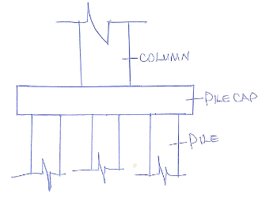
GROUP CAPACITY OF PILES
The capacity of a pile group is not necessarily the capacity of the individual pile multiplied by the number of individual pile in the group. Disturbance of soil during the installation of the pile and overlap of stresses between adjacent piles may cause the group capacity to be less than the sum of the individual capacities.
Conversely the soil between individual piles may become ‘locked in’ due to densification from driven and the group may tend to behave as a unit or equivalent single large piles.
Densification and improvement of the soil surrounding the group can also occur. These factors tend to provide the group a capacity greater than the sum of the capacities of individual piles.
Pile Group Efficiency
The efficiency n_{g} of a pile group is defined as the ratio of the group capacity Q_{g} to the sum of the capacities of the number of piles n in the group.
n_{g =}$\frac{Qg}{(ΣQp)}$ or $\frac{Qg}{n.Qp}$
Where Q_{p}= Capacity of individual pile
USES OF PILES
- Bearing piles are used to support vertical loads from the foundation of building and bridges. The load is carried either by transferring to the incompressible soil or rock below through soft strata or by spreading the load through soft strata that are incapable of supporting concentrated loads from shallow footings.
- Tension piles are used to resist upward forces in structures subjected to uplift such as buildings with basement below the ground water level, aprons of dams or buried tanks they are also used to resist overturning of walls and dams and for anchors of towers guywires and bulkheads.
- Laterally loaded piles support horizontal or inclined forces such as the foundations of retaining walls, bridges, dams and wharves and as fenders in harbor construction.
Example 001
A pile is driven in uniform clay of large depth. The clay has unconfined compression strength of 90 kN/m². The pile is 30cm in diameter and 6m long. Determine the safe frictional resistance of the pile, assuming a factor of safety of 3. Assume the adhesion factor $∝$= 0.7

Solution;
Note that Cohesion = $\frac{1}{2}$ of compression strength, hence
Cohesion of clay = ½ x 90 = 45 kN/m²
Frictional resistance = $∝$.C.A_{S}
= 0.7$×$ 45$×$0.3$π$ x 6
= 178.13 kN
Safe frictional resistance = $\frac{frictional resistance}{safe factor}$
= $\frac{178.13}{3}$ = 59.3 kN
Example 002
A group of 16 piles of 50cm diameter is arranged with a center to center spacing of 1.0m. The piles are 9m long and are embedded in soft clay with cohesion 30K_{N}/m². Adhesion factor is 0.6, baring resistance may be neglected. Determine the ultimate load capacity of the pile group.
Solution;
Given, n = 16, d = 50cm, L = 9m, C = 30 kN/m²
Width of group B = (1 x 3 + 0.5) = 3.5m
Q_{g} = C x 4B x 9
Q_{g} = 30 x 4B x 9
= 30 x 4 x 3.5 x 9 = 3780 kN for pile acting individually.
Q_{g} = n (∝. CA_{S})
= 16 x 0.6 x 30 x $π$ x 0.5 x 9
= 4,070 kN
Hence the foundation is governed by block failure and the ultimate load capacity is 3780KN.
The mode of failure of pile group in cohesive soils depend primarily upon the spacing of piles. For smaller spacing block failure may occur- that is the group capacity as a block will be less than the sum of individual pile capacities. For larger spacing, failure of individual pile capacities which will be smaller than the strength of the group acting as a unit or block.
Example 003
A square pile group of 9 piles pass through a recently filled up materials of 4.5m depth. The diameter of piles is 30cm and pile spacing is 90cm center to center. If the unconfined compression strength of the cohesive materials is 60 kN/m² and unit weight is 15 kN/m^{3.} Compute the negative skin friction of the pile group.
Solution;
Individual piles cohesion =$\frac{1}{2} x$ 60
= 30 kN/m²
Negative skin friction Q_{ng} = n x PD_{n}C
= 9 x $π x 0.3 x 4.5 x 30$
= 1145 kN
Block B = 2S + d = 2 x 0.9 + 0.3
= 2.1m
Negative skin friction
Q_{ng} = CD_{n}P_{s} + r. D_{n}A_{g}
= 30 x 4.5 x 8.4 + 15 x 4.5 x 4.41
= 1134 + 298
= 1432 kN
Pg = 4B = 4 x 2.1 = 8.4m
A_{g} = B² = (2.1)² = 4.41m²
SETTLEMENT ANALYSIS
Foundation of all structures have to be placed on soil. The structure may undergo settlement depending upon the characteristic such as compressibility of the strata of soil on which it is founded. The term settlement indicates the sinking of a structure due to the compression and deformation of the underlying soil. Clay strata often need a very long time to get fully consolidated under the loads from the structure while the settlement of a loose strata of cohensionless soil occur relatively fast. Thus, there are total settlement and the time rate of settlement.
Settlement analysis may be divided into three (3);
- Obtaining the soil profile which gives an idea of the depths of various characteristic zones of soil at the site of the structure and also the relevant properties of soil such as initial void ratio, grain specific gravity water content and the consolidation and compressibility characteristics.
- Analysis of the transmission of stresses to the subsurface strata using a theory such as Boussinessq’s for stress distribution in soil.
- Final settlement prediction based on concept from the theory of consolidation and data from 1&2.
The total settlement may be considered to consist of the following contribution.
- Initial settlement or elastic compression.
- Consolidation settlement or primary compression.
- Secondary settlement or secondary compression.
1. Initial settlement: it is also referred as the distortion or contact settlements rely on application of the foundation load. Such immediate settlement in case of partially saturated soils is primarily due to the expulsion of gases and to the elastic compression and rearrangement of particles. In case of saturated soil it is considered to be the result of vertical soil compression before any changes in volume occurs.
In cohensionless soil, elastic and primary compression occur less because of their high permeability. Standard penetration test (SPT) is used to evaluate immediate settlement.
Si= $\frac{H}{Cs}$ log_{e} $\left(\frac{σo+ ∆σ}{σo}\right)$
Where H = thickness of the layer getting compressed
$σ$_{o}= effective overburden pressure at the center of the layer before any excavation or application of load.
$∆σ$= Vertical stress increment at the center of the layer
Cs = Compressibility constant, given by Cs = 1.5 $\frac{Cr}{σo}$
Cr = Being the static cone resistance
$σ$_{o}= Being the effective overburden pressure at the point tested.
In cohesive soils, immediately settlement is given by
S_{i} = q.B $\left(\frac{1-V2}{Eo}\right)$ I_{t}
S_{i} = immediate settlement at a corner of a rectangular flexible foundation of size L$×B$
B = width of foundation
q = uniform pressure on the foundation
E_{O} = Modulus of elasticity of the soil
v = Poisson’s ratio of the soil
I_{t} = influence value which is dependent on L/B
For a perfect flexible square footing, the immediate settlement under its center is twice that at its corner.
The values of I_{i} are tabulated below;
L/B | 1 | 2 | 3 | 4 | 5
I_{t} | 0.56 | 0.76 | 0.88 | 0.96 | 1.00
(Influence factor I_{t} after Tertaghi, 1943)
The value of I_{S} are tabulated below
L/B | Circle | 1 | 2 | 5 | 10
I_{s} | 0.73 | 0.82 | 1.00 | 1.22 | 1.26
(Influence factor is after Skempton, 1951)
For a thin clay layer
S_{I}= q.B$\left(\frac{1-v2}{Eo}\right)$ I_{s}
Example 01
- A reinforced concrete foundation of dimension 18m x 36m exerts a uniform pressure of 180KN/m² on a soil mass with E value 45MN/m². Determine the value of immediate settlement under the foundation. Assume v = 0.5
Solution;
S_{i} = $\frac{q.B(1-V2)}{Es} x$ I_{S}
E₃ = 45 MN/m² = 45000 kN/m²
v = 0.5, q= 180 kN/m², B= 18m, L =36m, I_{S} for L/B = 2 is 1
S_{I} = $\frac{180 x 18 [1-\left(0.5\right)2]}{45000} x 1$
= 0.054
= 54mm
Example 02
The plan of a proposed spoil heap is shown in a figure below. The heap will stand on thick, soft alluvial clay with the E-value 18MN/m^{2.} The eventual uniform bearing pressure on the soil will be about 270 KN/m². Estimate the immediate settlement under the point X at the surface of the soil.
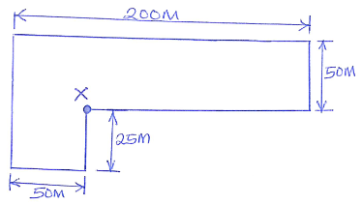
Solution;
The area is to be divided into rectangles such that X forms one of the corners for each as shown below.
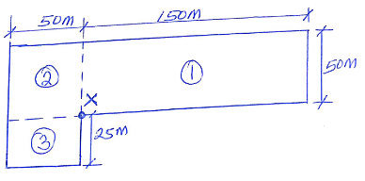
The structure is flexible and the soil deposit is thick.
S_{i} = $\frac{q.B(1-V2)}{Es},$ I_{S}
I_{t} = Terzaghi influence value dependent on L/B.
By principle of super position
S_{i} = q$\left(\frac{1-V2}{Es}\right)$ (I_{t1}B₁ + I_{t2}B₂ + I_{t3}B₃)
For rectangle 1: L/B = (150/50) = 3, I_{t1} = 0.88
For rectangle 2: L/B = (50/50) = 1, I_{t2} = 0.56
For rectangle 3: L/B = (50/25) = 2, I_{t3} = 0.76
Es = 18 MN/m² = 18000 kN/m²
q = 270 kN/m², assume v = 0.5
Si = $\frac{270 x [1-\left(0.5\right)2]}{18000} x [\left(0.88 x 50\right)+\left(0.56 x 50\right)+\left(0.76 x 25\right)]$
= $\frac{270 x 0.75}{18000}$ x 91
= 1.024m
FACTORS AFFECTING SETTLEMENT
- Rigidity of a structure: Average load must be used with respect to time rather than maximum value especially during the early stage of settlement; however, column and footing must be designed for maximum load.
- Horizontal draining: Difference in hydrostatic excess pressures at the same depth at different points underneath a loaded area especially if the structure is supported on piles or columns carrying different loads. This create horizontal flow due to the gradients in the horizontal directions.
- Accuracy of computer settlement: The accuracy of the compute settlements is naturally dependent upon the degree or extent to which the assumption involved in the theories made use of in the analysis are valid in any given case.
Remedial measures against Harmful settlement.
Settlement of a soil is a natural phenomenon and may be considered to be unavoidable. However, a few remedial measures are possible against harmful settlement.
- Removal of soft soil strata consistent with economy.
- The use of properly designed and constructed pile foundation.
- Building slowly on cohesive soils to avoid lateral expansion of a soil mass and to give time for the pore water to be expelled by the surcharge load.
- Pre-consolidation of a building site long enough for the expected load depending upon the tolerable settlements, alternatively any other method of soil stabilization.
LATERAL EARTH PRESSURE AND RETAINIG WALL
Lateral earth pressure is the force exerted by the soil mass upon an earth retaining structure.
The typical structures whose purpose is to resist earth pressure may include retaining walls, sheet pillar braced sheeting of pits and trenches abutment. These may be self-supporting by means of bracing or anchored tied.
Active pressures are accompanied by movement directed away from the soil. Passive pressures are accompanied by movement towards the soil.
Logically, therefore there must be a situation intermediate between the two when the retaining structure is perfectly stationary and does not move in either direction. The pressure develops in this conduction is called earth pressure at rest.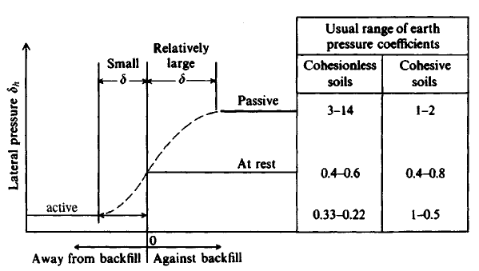
Figure 1: Illustration of active and passive pressures with usual range of values for cohesionless and cohesive soil.
A retaining wall is defined as a structure whose primary purpose is to prevent lateral movement of earth or some other materials. Retaining wall is also used to retain water, coal. It does not required bracing for stability. It is idly use in variety of purposes which include Hiss side road, elevated and depressed roads, landscaping, canals and locks, floodwalls, bridge abutment and erosion protection.

Example 1
Given a retaining wall as shown in the figure, calculate the thrust

10m $ɤ=18K$_{N}/m³
$∅=30°$
C = 0, $σ=0$
Solution;
K_{a} =$\frac{1-sinθ}{1+\sin{θ}}$
= $\frac{1-sin30}{1+\sin{30}}$ = $\frac{1- 0.5}{1+ 0.5}$ = $\frac{0.5}{1.5}$ = $\frac{1}{3}$
$σ$_{a} = $ɤK$_{a}h – 2c $\sqrt{K}$_{a}
= 18 x 10 x $\frac{1}{3}$ = 60 kN/m²
Thrust P_{a} = $\frac{1}{2 }$bh = $\frac{1}{2} x 60 x 10=300$ kN/m
At ${ 10}/3$ = 3.33m from the base.
Example 2
A retaining 6m high, retains dry soil with an angle of friction of 30º and unit weight of 16.2 KN/m². Determine the earth pressure at rest. If the water table rises to the top of the wall, determine the increase in the thrust on the wall. Assume the sub merged unit weight of sand is 10KM/m³.
Solution;
a. Dry backfill
$∅=30°, h=6, k$_{o}= 1- sin30º = 1 – 0.5 = 0.5
$σ$_{o} = $ɤK$_{o}h = 16.2 x 0.5 x 6
= 48.6 kN/m²
Thrust P_{a} = $\frac{1}{2}$b h = $\frac{1}{2}$ x 48.6 x 6
= 145.8 kN
b. water level at the top of the wall effective lateral earth thrust
P_{o} = $\frac{1}{2}ɤK$_{o}h²
= $\frac{1}{2} x 10 x 0.5 x 6$²
= 90 kN/m. run
Neutral lateral pressure
P_{w} = $\frac{1}{2}ɤ$_{w}h²
=$\frac{1}{ 2} x 10 x 6$²
= 180 kN/m. run
Total thrust = 90 + 180 = 270 k/m run
Increase in thrust = 270 – 145.8 = 124.2 kN/m run
Note (tension crack is a slip in cohesive soil caused gap)
Example 3
Determine the depth of the tension crack and the thrust in the figure below

6m $ɤ=18K$_{N}/m³
$∅=10°$
C = 40 K_{N}/m²
Solution;
K_{a} =$\frac{1-sinθ}{1+\sin{θ}}$
= $\frac{1-sin10}{1+\sin{10}}$ = 0.705
$σ$_{a} = $ɤK$_{a}h – 2c $\sqrt{K}$_{a}
h= o, = 0 – 2 x 40 x$\sqrt{0.705}$
= - 67.2 K_{N}/m²
h=6, = 18 x 6 x 0.705 – 67.2
76.14 – 67.2 = 8.94 kN/m²
To get the tension crack
h_{i} = $\frac{2c}{ɤ\sqrt{Ka}}$ = $\frac{2 x 40}{18\sqrt{0.705}}$ =$\frac{80}{15.11}$ = 5.29m
h = 5.3m

SHEET PILE
A sheet pile wall is a flexible retaining wall which does not depends on its weight for stability, unlike gravity wall. It depends on the passive resistance of the soil in front and behind the lower part of the wall. It may also be supported by anchor or struts. It consists of series of sheet piles driven side by side into the ground.
Forming a continuous vertical wall for the purpose of retaining on earth banks. Sheet pilling walls are commonly used for;
(1) Water front construction where other types of retaining wall will required dewatering the site
(2) Temporary construction because of the high salvage value of sheet piles.
(3) Light weight construction at locations where the upper layer or layers of sub soils are inadequate for supporting retaining wall.
Coulomb’s Wedge
Coulomb’s Wedge Theory developed a method to determine the earth pressure in which he considered the equilibrium of the sliding wedge which is formed when the movement of the retaining wall takes place.
The sliding moves downward and outward related to the back front in active case whereas in passive case, the sliding wedges moves upwards. The lateral pressure on the wall is equal and opposite to the reactive force exerted by the wall in order to keep the sliding wedge in equilibrium.
Assumptions
- The backfill is dry, cohensiveless homogenous isotropic and ideally plastic material.
- The slide surface is a plane surface which passes through the heel of the wall.
- The wall surface is rough. The resultant earth pressure in the wall is inclined at an angle to the normal to the wall where $σ$ is the normal to the wall where $σ$ is the angle of the friction between the wall and the backfill.
- The sliding wedge itself acts as a rigid body
K_{a =} $\frac{Sin2(β + ∅)}{Sin2 β Sin\left(β + σ\right) \left(1+ \frac{\sqrt{Sin\left(θ+σ\right) Sin (θ-σ)}}{Sin \left(β- σ\right) Sin (β+ σ)}\right)}$

The line of action of P_{a} will be at height $H/3$ where the base of the wall and it uni indeived at angle $σ$ to the normal drawn to the back of the wall.
P_{a} = $\frac{1}{2}$ K_{a} $∝$ H²
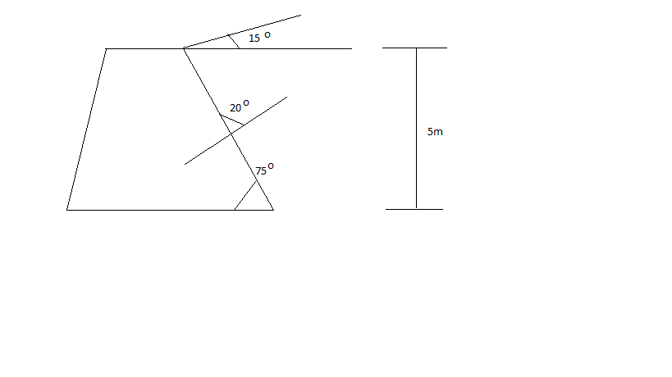
Determine the coulomb active force on the retain wall.
K_{a} = $\frac{Sin2(75° + 30°)}{Sin2 75° Sin\left(75° + 20\right) \left(1+ \frac{\sqrt{Sin\left(30°+20°\right) Sin (30)}}{Sin (75-20°)}\right)}$
K_{a} = $\frac{0.933}{0.933 ×0.819 \left(1+ \frac{\sqrt{0.766 ×0.259}}{0.819 ×1}\right)}$²
= 0.548
P_{a} = $\frac{1}{2}$ K_{a} $∝$ H²
= $\frac{1}{2}$ $×$ 0.548 $×$ 17.5 $×5$²
= 119.9K_{N}
K_{P}$=\frac{Sin2(β + ∅)}{Sin2 β Sin\left(β + σ\right) \left(1- \frac{\sqrt{Sin\left(θ+σ\right) Sin (θ+σ)}}{Sin \left(β+ σ\right) Sin (β+ σ)}\right)}$
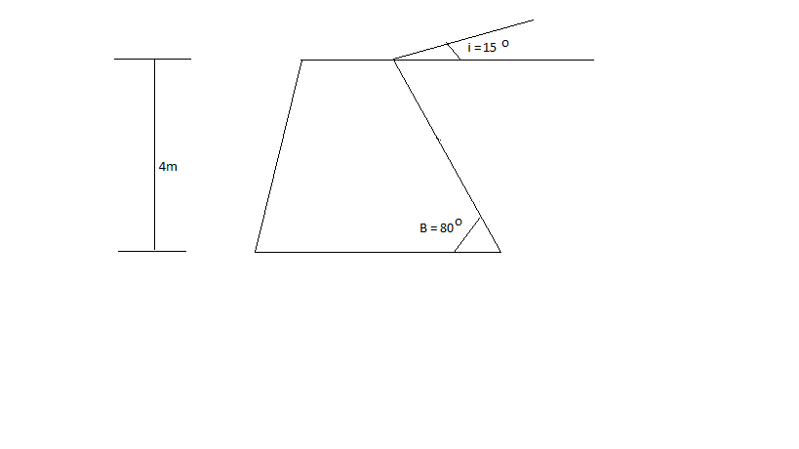
Determine the active pressure on the wall as shown below using Rankine Theory.
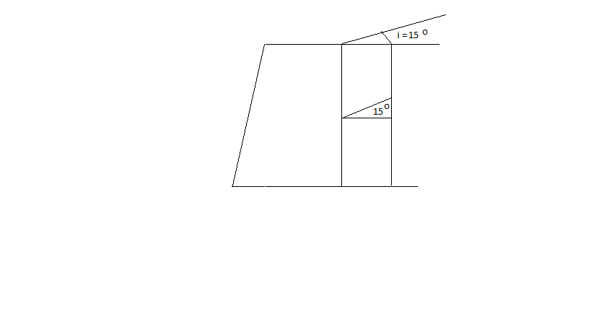
K_{a} = Cosi$× \frac{cosi-\sqrt{\cos^{2}i-\cos^{2}∅}}{cosi+\sqrt{\cos^{2}i-\cos^{2}∅}}$

K_{a} = Cosi 15$° × \frac{cosi 15°-\sqrt{\cos^{2}15°-\cos^{2}30°}}{cos15°+\sqrt{\cos^{2}15°-\cos^{2}30°}}$
= 0.373
P_{a} = $\frac{1}{2}$ K_{a} $∝$ H²
= $\frac{1}{2}$ $×$ 0.373 $×$ 1.9 $×4$²
= 56.7K_{N}
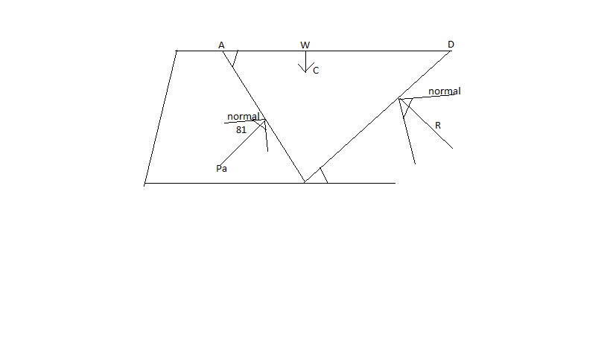
The sliding wedge ABD is in equilibrium under 3forces
- Weight of the wedge W
- The reactive R on the surface BD
- Reaction P_{a} from the wall

